MYSQL ADVANCED PROJECT ASSIGNMENT

Q1. Create an ER diagram or draw a schema for the given database.

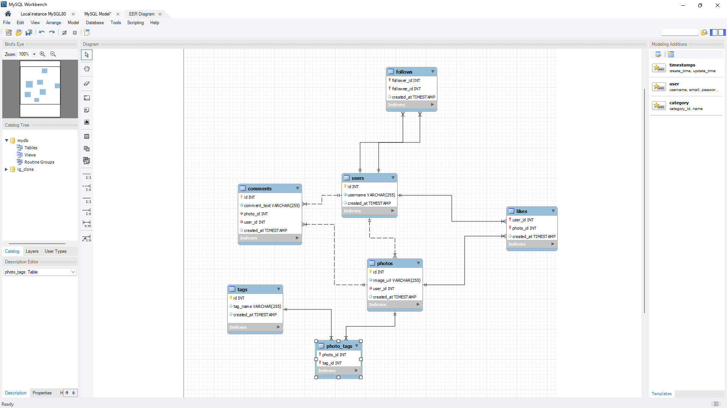

Q2. We want to reward the user who has been around the longest, Find the 5 oldest users.

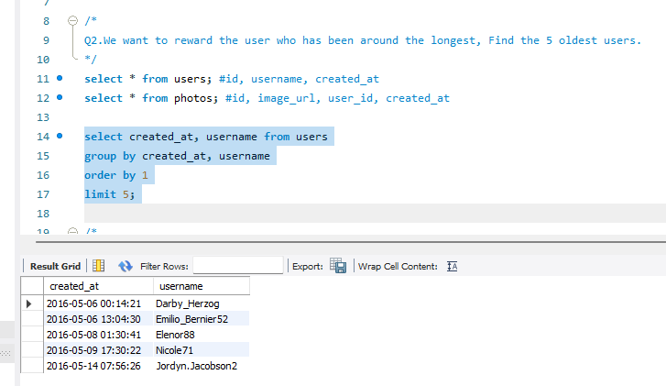

Q3. To target inactive users in an email ad campaign, find the users who have never posted a photo.

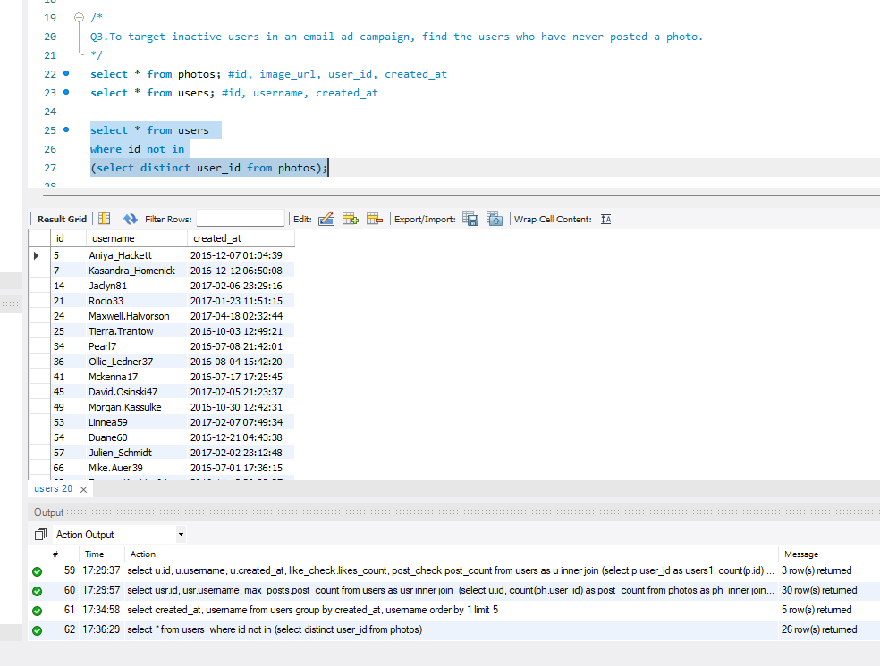

Q4. Suppose you are running a contest to find out who got the most likes on a photo.

Find out who won?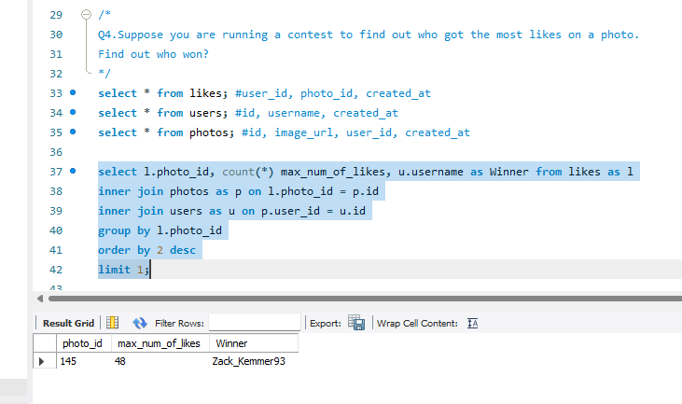

Q5. The investors want to know how many times does the average user post.

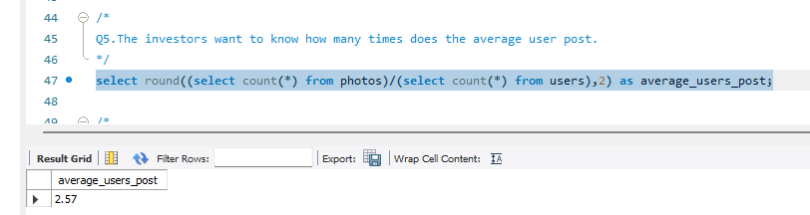

Q6. A brand wants to know which hashtag to use on a post, and find the top 5 most used hashtags.

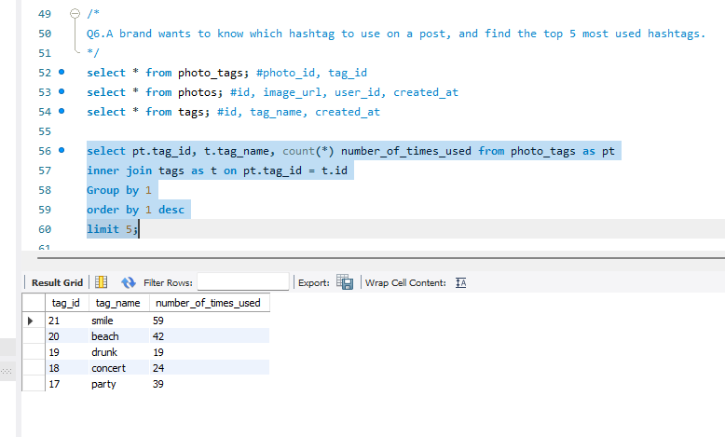

Q7. To find out if there are bots, find users who have liked every single photo on the site.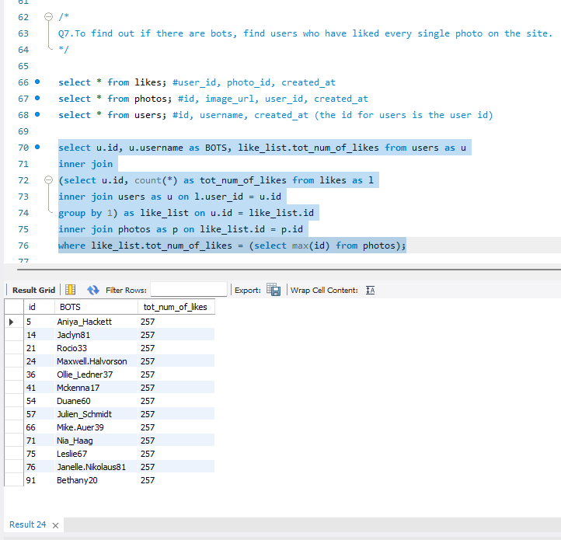

Q8. Find the users who have created instagramid in may and select top 5 newest joinees from it?

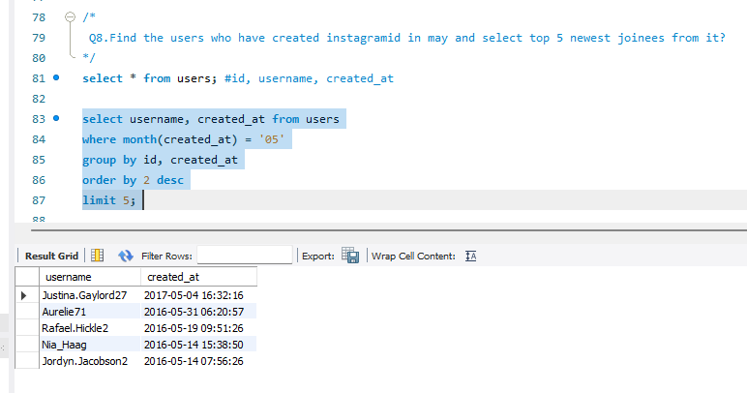

Q9. Can you help me find the users whose name starts with c and ends with any number

and have posted the photos as well as liked the photos?

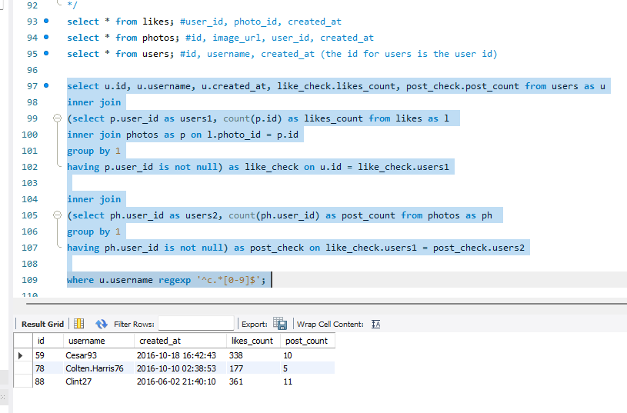

Q10. Demonstrate the top 30 usernames to the company who have posted photos in the range of 3 to 5.



